From 'Brexit' To Trump, Nationalist Movements Gain Momentum Around World

June 25, 20165:00 AM ET

Scott Detrow

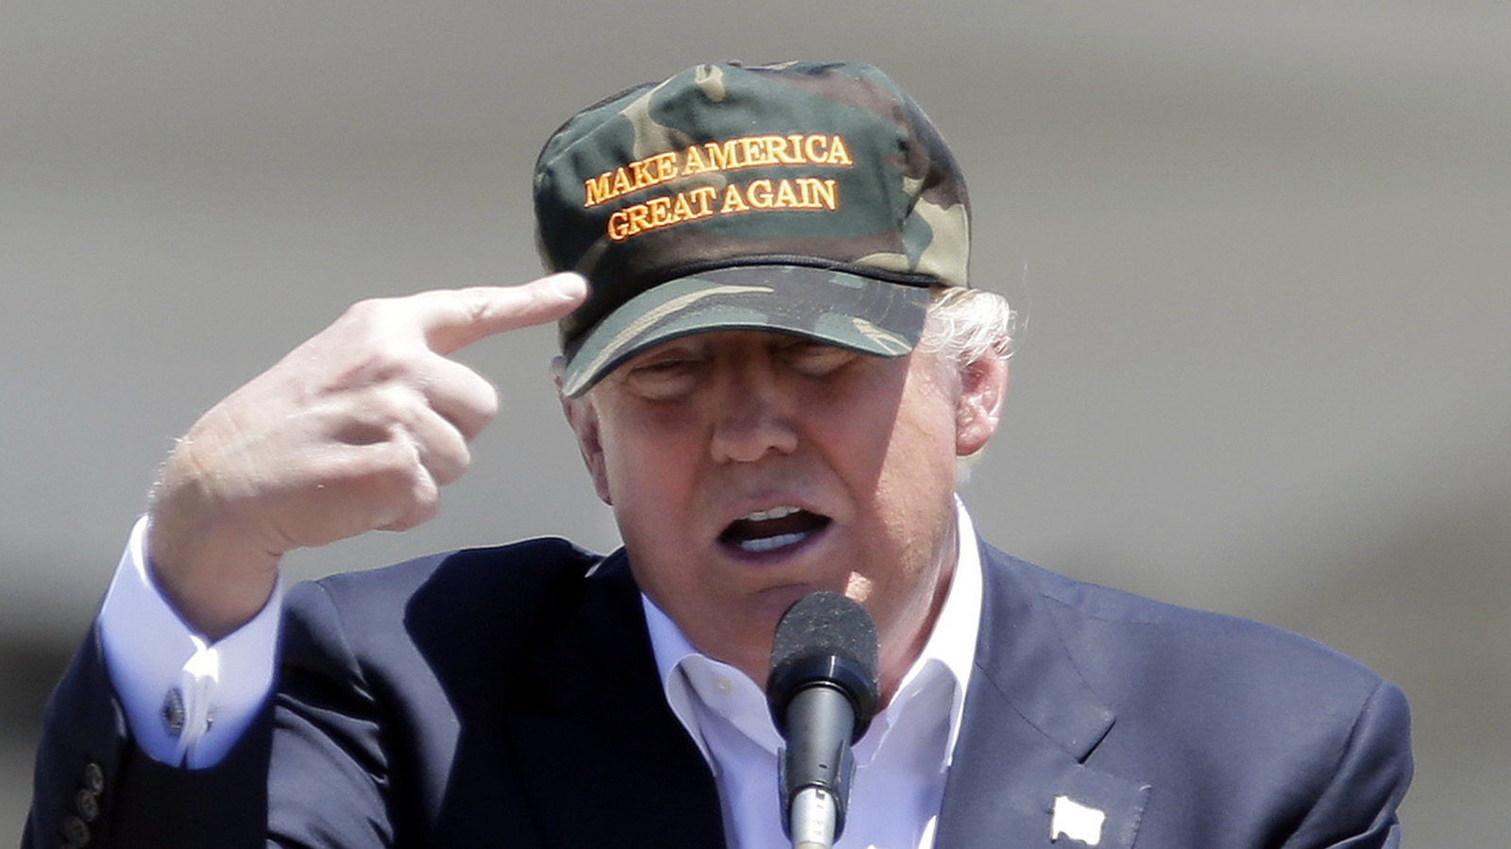

When Donald Trump arrived in Scotland Friday morning, hours after the United Kingdom voted to leave the European Union, the presumptive Republican presidential nominee was quick to draw parallels between the U.K.'s political earthquake, and his own campaign for president.

"People want to take their country back," Trump said, "They want to have independence, in a sense. And you see it in Europe, all over Europe."

And while Scotland itself voted overwhelmingly to remain in the European Union, Trump is right. Right-wing nationalist movements, fueled by anger toward political elites and mistrust of immigration — and primarily backed by white voters — are gaining more and more momentum on the continent.

"This is not a unique phenomenon to the United States, and 2016 is not a short moment that will pass," says Yascha Mounk, who teaches political theory at Harvard University and has studied the rise of nationalist movements. "This is a real populist turn that has been happening for the last 15 or 20 years."

In recent decades, nationalist movements have shifted from vocal minorities to powerful parties that gained control of governments in places like Hungary, have lost national elections by the slimmest of margins in countries like Austria, and, this week, forced the United Kingdom out of the European Union.

Mounk pegs economic stagnation among lower- and middle-class whites as a main driver for nationalism's rise around the globe. "You have a socially descending middle class that hasn't had real gains in the standard of living in 30 years," he said. "And at the same time, you seem to have real improvements in social status, if not necessarily economic status, for ethnic minorities. So they feel like our country is being taken away."

Add to that mix an immigration and refugee crisis tied to Syria's civil war, which has flooded European countries, especially, with scores of migrants looking for jobs, social-services protections and housing.

While each movement has its own unique characteristics, there are many similarities that are fueling nationalism in the United States, the U.K. and other European nations.

**A contempt for the elite ruling classes**

"People feel, quite rightly, that they have no real control over political systems — that the political class does what it wants and it sort of ignores ordinary people," Mounk says. "And to a large extent, that's because of the necessities of globalization."

The contempt was clear in the victory speech of Nigel Farage, the head of the U.K. Independence Party and a leading voice in the long push for the U.K. to disassociate from the EU.

"This will be a victory for the real people, a victory for the ordinary people," he said early Friday morning when it was clear the Leave campaign had won the referendum. "We have fought against the multinationals. We fought against the big merchant banks. We fought against big politics."

Trump has sounded similar calls throughout his campaign.

"We'll never be able to fix a rigged system by counting on the same people who have rigged it in the first place," Trump said [earlier this week](http://www.npr.org/2016/06/22/483100251/fact-check-trumps-speech-on-clinton-annotated), adding, "It's rigged by big donors, who want to keep wages down. It's rigged by big businesses who want to leave our country."

While the feeling has largely gone mainstream in recent years — both of those quotes could have been said by Vermont Sen. Bernie Sanders — anti-elite sentiments have been a key part of nationalist parties' persona for decades.

**Blaming immigrants**

After the ISIS-inspired mass shooting in San Bernardino last December, Trump amped up warnings about Syrian refugees immigrating to the United States. He called for an across-the-board halt of all Muslims entering the country, warning they carried the risk of additional terror attacks.

While many Republicans hoped Trump would back away from his proposed ban on an entire religion, he embraced it even tighter after the Orlando shootings.

"We need to tell the truth, also, about how radical Islam is coming to our shores," Trump said in the wake of the attack. "And it's coming. With these people, folks, it's coming."

Trump even blamed "Muslim communities," en masse, for failing to tip off authorities about both the Orlando and San Bernardino attacks.

"The idea of nativism — of seeing your country under threat by non-natives, specifically immigrants and Muslims, is something that Marine Le Pen and Donald Trump clearly share," says Cas Mudde, a University of Georgia professor, who specializes in nationalist movements.

Le Pen heads the National Front party in France. In the wake of last year's Paris terror attacks, [she told NPR](http://www.npr.org/2015/11/16/456254001/frances-national-front-leader-criticizes-hollandes-response-to-paris-attacks) that France needed "to institute a major policy, which would reestablish our own borders. This means we need to stop accepting this influx of immigrants."

She called the continued flow of Syrian refugees into Europe "madness" and urged for an end to the open-border policy that is a hallmark of the European Union.

"I think when people are disappointed and hurt and angry, they revert to a very basic part of human psychology," Mounk says. "And that is in-group versus out-group. Us versus them. And it's always easy to blame immigrants."

It can be popular, too. Exit polls conducted throughout the Republican primaries this year consistently showed a solid majority of GOP voters supporting Trump's call for a temporary ban on Muslim immigration.

**Simple solutions**

Mounk says the basic approach of many populist, nationalist candidates can be boiled down to this: "I embody the will of the people. And the problems that we face are actually completely straightforward," he said. "The problem is that the elites are corrupt. They're in cahoots with minorities, with business interests. And all that needs to happen is for me to be elected."

It's a sentiment that can be heard in Trump's most recent major campaign speech. "When I see the crumbling roads and bridges, or the dilapidated airports, or the factories moving overseas to Mexico, or to other countries for that matter," he said, "I know these problems can all be fixed. But not by Hillary Clinton. Only by me."

The best example of a simple solution to a complex problem: Trump's vow to curtail immigrants from entering the country illegally by building a wall across the U.S.-Mexico border — and forcing Mexico to foot the bill.

Hungary's Prime Minister, Viktor Orban, is perhaps the most high-profile nationalist politician to head a nation. He went ahead and built a wall of his own last year in an attempt to stem the flow of migrants from Syria.

"Many people criticize the physical barrier we are just setting up at this moment in Hungary," he said at the European Union headquarters in Brussels last year. "I ask everybody — all the European leaders — what else ideas they have."

**Is nationalism here to stay?**

It's clear that the factors galvanizing nationalist sentiments aren't going anywhere any time soon. Western democracies continue to become increasingly multicultural. Globalization will remain — despite attempts to stop it, like the U.K.'s Brexit vote.

And the most powerful factor — economic stagnation — appears more likely to remain, too. The Brexit vote triggered market turmoil around the globe Friday, raising questions about long-term economic affect of the move.

So nationalism will continue to be a powerful political tool, and it's clear Trump will embrace the theme through the November election, seeing Brexit as fuel.

"I really do see a parallel between what's happening in the United States and what's happening here," he said in Scotland Friday. "People want to see borders. They don't necessarily want people pouring into their country that they don't know who they are and where they came from. They have no idea."

How much is nationalism at the core of Trump's political ethos? At the end of his speech Wednesday, Trump veered off script into an almost stream-of-consciousness mantra.

"Americans, Americans," he said. "The people that we love."

"Americans," he continued. "America first. Make our country great again.

"Americans."